NAME: Maryam Abdikadir Ahmed
ID: C6240019
SUBJECT: LINUX ASSIGNMENT COMMANDS

- Ls /
Explanation: the ls / command displays the main directories and files located in the root
Directory of the linux filesystem

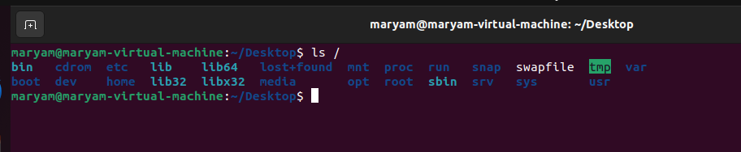

- cat /proc/meminfo
Explanation: this command display information about the computer’s cpu
Including processor details and features.

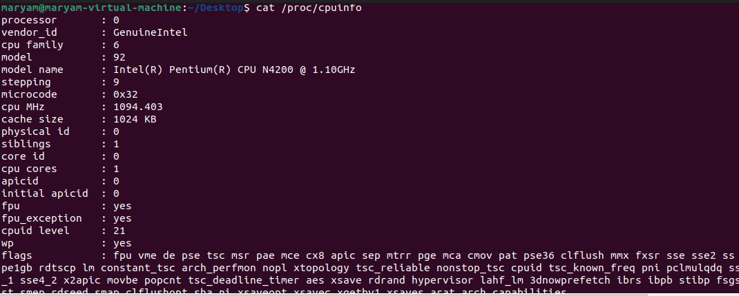

- cat /proc/meminfo
Explanation: this command display information about the system’s memory, including total memory and available memory.
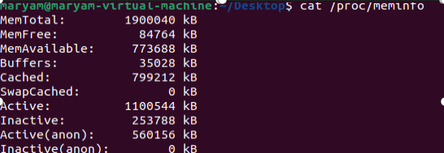
- Ls /sys/class/net
Explanation: this command display the network interface detected
By the linux kernel

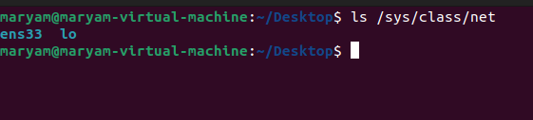

2.2 The Terminal and Bash

5. echo $SHELL
Explanation: this command display the path of the user’s default shell.on ubuntu,it commonly display /bin/bash.

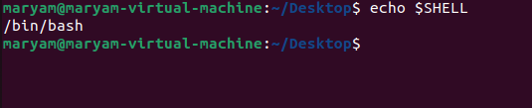

- History
Explanation: the history command displays anumbered list of
Commands previously executed in the Bash terminal
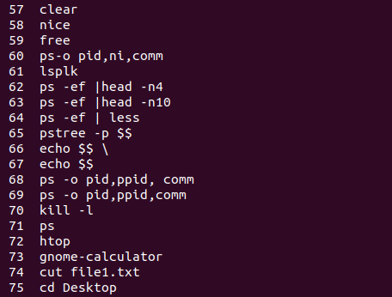
- cat ~/.bash_history
Explanation: this command displays the Bash command
History seved in the user’s home directory. the file may not contain the current session’s latest command until Bash saves them
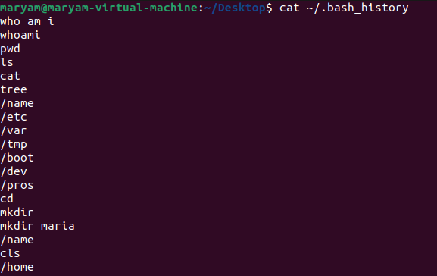

- Pwd

Explanation: the pwd command displays the full path of the
Current working directory

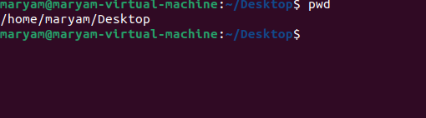

2.3 command syntax and option

- ls -a

Explanation: this command display all file and directories,
Including hidden files that begin with a dot.
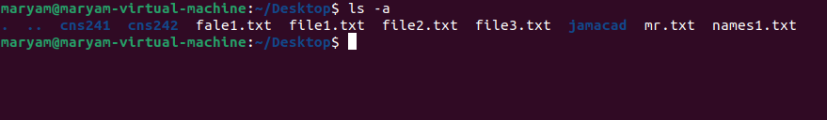

- ls --all
Explanation: this command performs the same function as
Ls -a. the --all option displays hidden files and directories.
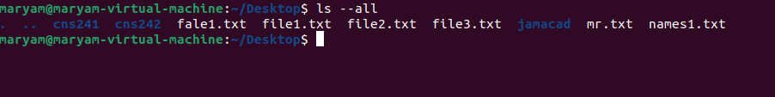

- ls -l
Explanation: this command displays files and directories in long
Format,including permissions,owner,file size, and modification date.
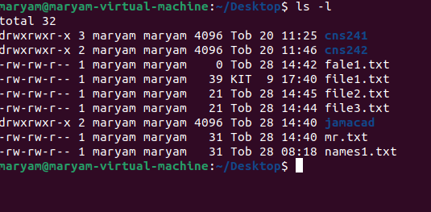
- Ls --format=long

Explanation: this command display directory contents in long
Listing format, providing detailed information about each item.

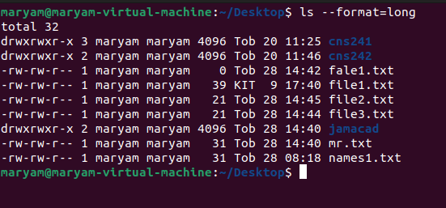

- ls -lh

Explanation: this command displays files in long format and
Shows file sizes in a human -readable format,such as KB,MB and GB.
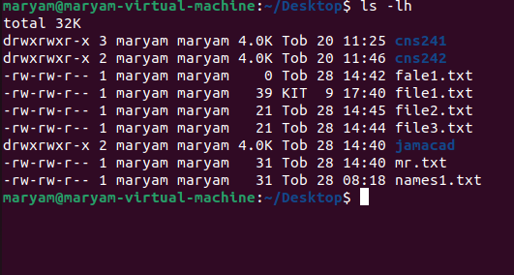

- ls -la

Explanation: this command display all files,including hidden
Files, in long listing format.

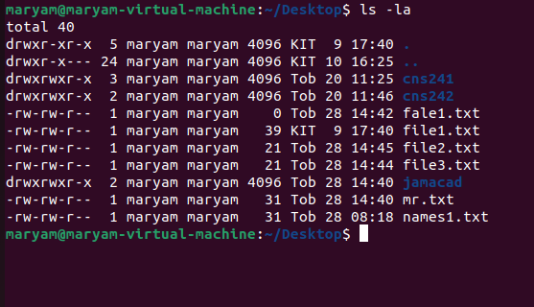

- mkdir -p projects/linux

Explanation: this command creates adirectory named projects
And subdirectory named linux. The -p option creates parent
Directories when necessary.

- Man ls

Explanation: this command opens the manual page for the ls
Command. It provides information about usage,options,exaples.
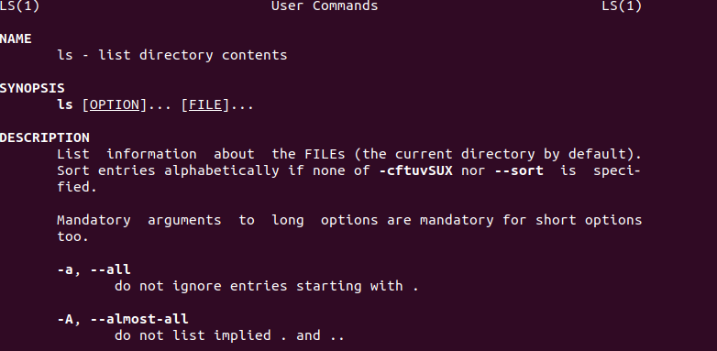

- man rmdir

Explanation: this command opens the manual page for rmdir,
Which explains how to remove empty directories.

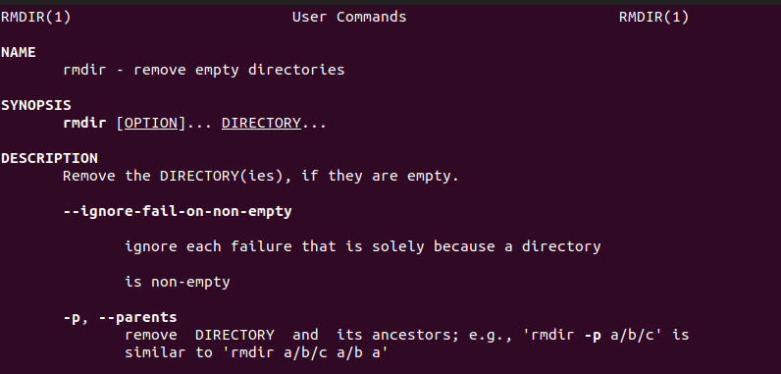

- Help

Explanation: this command display a list of bash built-in
Commands and provides basic informaton about them.
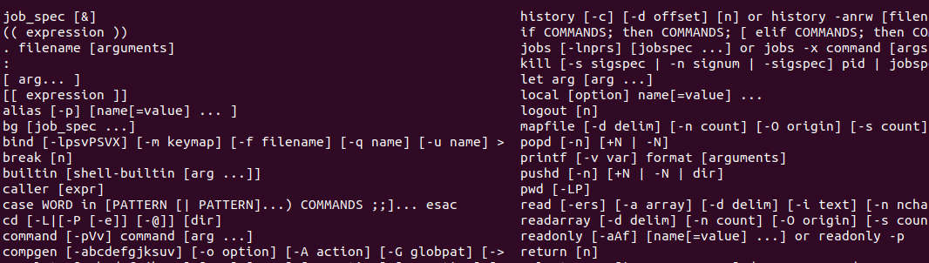

- echo Hello
This command displays the word Hello on the terminal screen
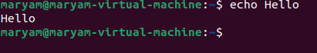

- Echo “Hello $USER”

Explanation: this command display the word Hello followed
By the current username. Double quotes allow variable expansion.
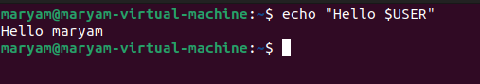

- touch “new file.txt”

Explanation: this command creates an empty file with the
Name new file.txt double quotes allow space in filename
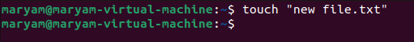
- COURSE=linux

Explanation: this command creates a shell variable named COURSE and assigns the value linux to it. Do not put spaces
Around the equal sign.
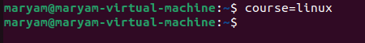

- echo $course

Explanation: this command displays the value stored in
The course variable
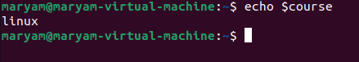

- ls /usr/bin/mkdir

Explanation: this command checks whether the mkdir
Excuitable exists in the /usr/bin directory


- Cd /

Explanation: this command changes the current working
Directory to the root directory of linux

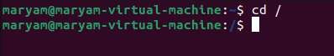

- cd ~

Explanation: this command takes the user directly to their home directory.
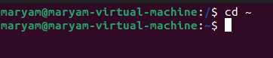

- Cd ..

Explanation: this command moves the user one
Directory level up to the parent directory.
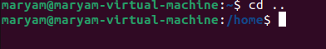

- Ls -l /etc

Explanation: this command displays detailed information
About the contents of the /etc directory, which stores many
System configuration files.

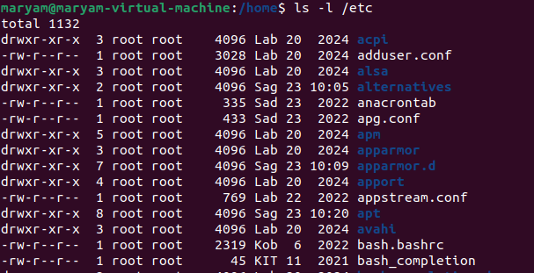
- mkdir -p ~/ch2lab/notes

Explanation: this command creates a directory named ch2lab
Inside the home directory and creates a subdirectory named notes.
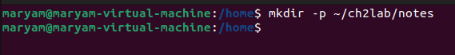

- mkdir ~/ch2lab/backup

Explanation: this command creates adirectory named
backup inside ch2lab.

- Cd ~/ch2lab

Explanation: this command changes the current working directory to the ch2lab directory inside the user’s home directory.
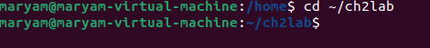

- touch notes/day1.txt notes/day2.txt “notes/week 3.txt”

Explanation: this command creates three empty text files inside
The notes directory. Quotation marks allow the third file name
To contain space.

- ls -l notes

Explanation: this command displays the files inside the notes
Directory in long listing format.
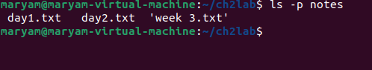

- Ls -a ~

Explanation: this command displays all files and directories
In the home directory, including hidden files.
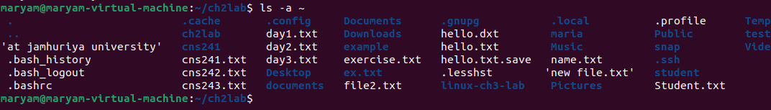

- cp notes/day1.txt backup/

Explanation: this command copies day1.txt from the notes directory into the backup directory.
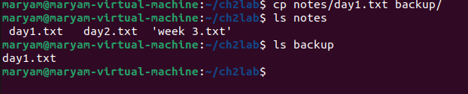

- mv notes/day2.txt notes/monday.txt
Explanation: this command renames day2.txt to
Monday.txt inside the notes directory.

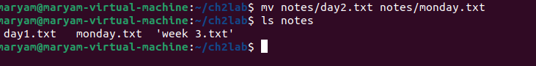
- cp -r notes notes-copy

Explanation: this command copies the entire notes directory
And its contents into a new directory named notes-copy
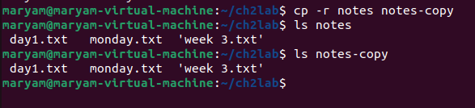

- echo $PATH

Explanation: this command displays the list of directories used
By the shell to locate executable commands.

- man rmdir

Explanation: this command opens the manual page for the
rmdir command and explain its usage and available options.

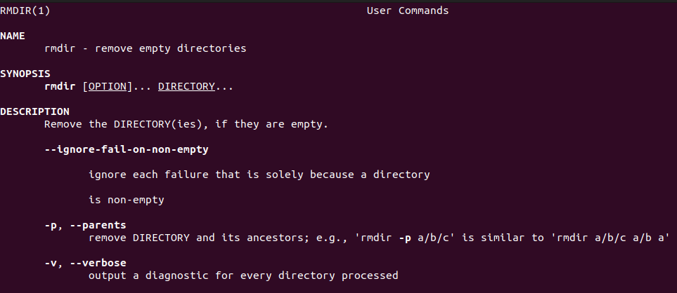

- Cat names1.txt

Explanation: the cat command displays the contents of the
Names1.txt file on the terminal screen.
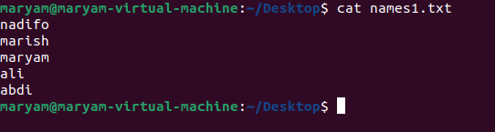

- tail -n 2 names1.txt

Explanation: this command displays the last two lines of the names1.txt file.
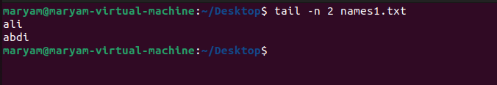

- head -n 2 names1.txt

Explanation: this command displays the first two lines of the
Names1.txt
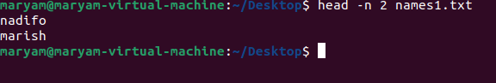

- file names1.txt

Explanation: this command identifies and displays the actual
File type of names.txt.
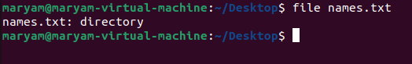
- which ls

Explanation: this command searches the directories in the PATH environment variable and displays the location of the ls executable.
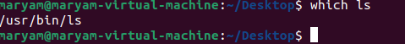

- grep ‘ali’ names1.txt

Explanation: this command searches the names1.txt file and displays lines containing the text Ali.
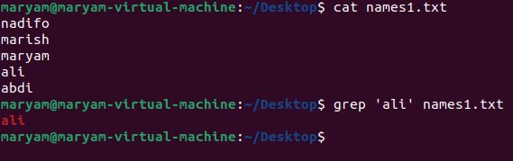
- echo $HOME

Explanation: this command displays the path of the current
User’s home directory.
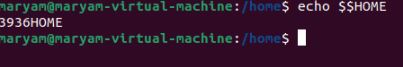
- rm names1.txt
Explanation: this command deletes the file named names1.txt
The deletion normally does not move the file to the Trash.


